**How To Outsource Recruiting**

Recruitment process outsourcing is a strategy where businesses delegate their recruitment services to a specialized third-party firm or individual. This approach involves the meticulous tasks of sourcing, screening, and suggesting the most suitable candidates for different positions within an organization.

The objective of this article is to assist enterprises in grasping the myriad advantages of choosing to outsource recruitment. We'll delve deeper into the nuances of the recruitment outsourcing method, highlight the most effective steps to seamlessly incorporate it, and provide valuable tips to ensure the overarching success of this crucial initiative.

## **Benefits of Outsourcing Recruiting**

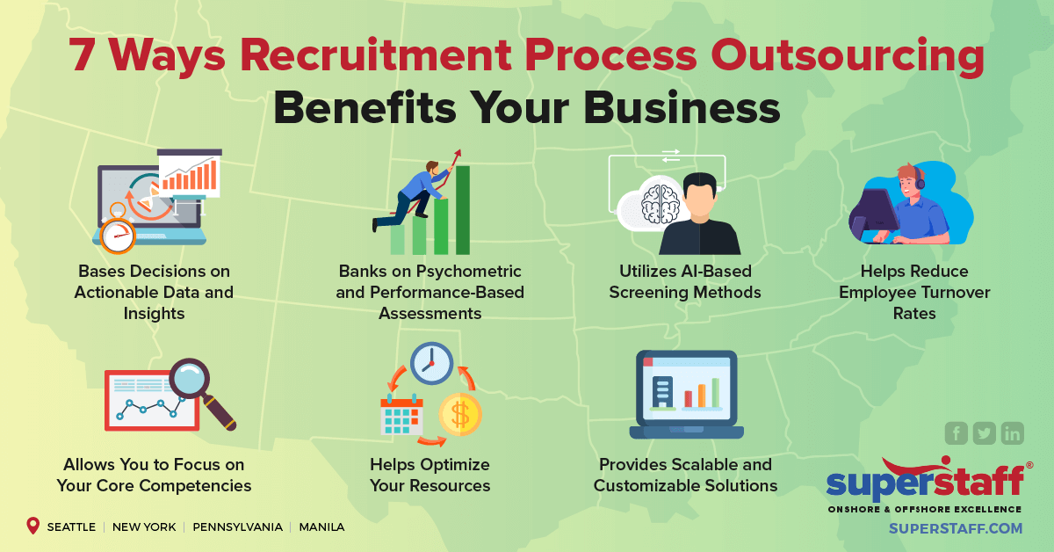

[Source](https://www.superstaff.com/wp-content/uploads/2021/08/7_Ways_Recruitment_Process_Outsourcing_Benefits_Your_Business.png)

### **Cost Savings**

Many times, companies outsource hiring through recruitment process outsourcing (RPO) because it effectively removes the necessity for internal hiring managers and resources. This approach leads to substantial cost savings, especially considering infrastructure, technology, and staffing expenses. The benefits of having recruitment process outsourcing performed become evident when assessing the overall impact on the organization's budget and recruitment process outsourcing RPO efficiencies.

### **Improved Customer Satisfaction**

Third-party RPO providers specializing in pinpointing the ideal candidates expedite the hiring processes and enhance employee-customer interactions. By allowing companies to focus on their core business functions, the growth outsourced recruiting offers can provide a competitive advantage to staffing companies. With the expertise of an RPO provider, firms are better positioned to harness the best talent, giving them an edge in their respective industries.

### **Access to a Larger Pool of Talent**

Recruiting firms possess expansive networks and a wealth of resources, which they can leverage throughout the entire hiring process. This grants companies, especially those focusing on in-house recruitment, a distinct advantage by offering them access to a more comprehensive and diverse pool of candidates. By integrating such recruitment processes, businesses can optimize their core business operations and ensure they attract top-tier talent.

### **Improved Efficiency**

Specialized recruiting agencies with a proven track record in their niche have the expertise and capability to streamline hiring procedures. Their well-structured approaches and experienced recruitment team ensure that vacant positions within an organization are filled promptly. Moreover, they guarantee that these roles are occupied by candidates who are not just a good fit for staffing company but are indeed the most suitable and aligned with the company's vision and needs.

### **Scalability**

Outsourcing recruiting offers businesses a flexible advantage, enabling them to adapt and scale their hiring processes in response to fluctuating needs. This flexibility ensures they can ramp up or dial down recruitment efforts as necessary while avoiding the limitations and overheads of relying solely on in-house resources.

### **Expertise in Niche Areas**

Numerous recruiting agencies possess expertise in particular industries or roles, allowing them to have a nuanced understanding of the unique requirements and challenges inherent in those sectors. This specialization enables them to sift through the talent pool meticulously, ensuring that they identify and recommend only the best candidates perfectly tailored for specialized positions and can add substantial value to the organizations they join.

### **Reduced Time-to-Hire**

These firms are exclusively dedicated to the art and science of recruiting, so they have honed their skills, methodologies, and resources to perfection. As a result, they can dramatically cut down the duration from the initiation of a candidate search to the final onboarding, often far more efficiently than in-house teams spread thin with diverse responsibilities. This efficiency ensures minimal disruption, allowing business operations to flow seamlessly and positions filled with adept candidates in record time.

## **Steps for Outsourcing Recruiting Effectively**

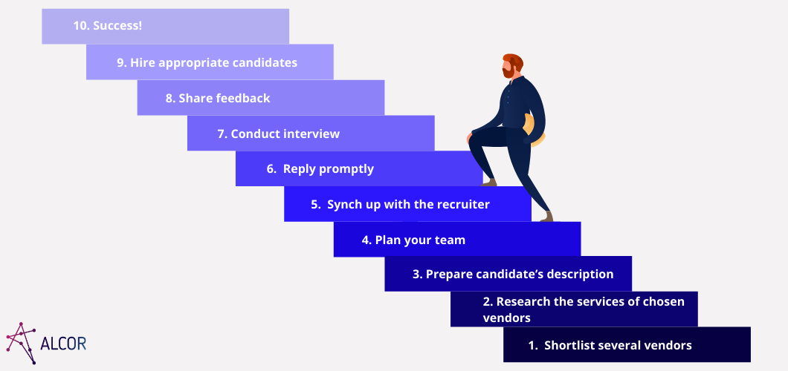

[Source](https://alcor-bpo.com/wp-content/uploads/2021/02/Shortlist-several-vendors.png)

### **1. Define Your Customer Service Needs**

Specify and precisely outline the particular requirements, qualifications, and traits you desire in potential candidates. This involves identifying the educational background, professional experience, skill sets, and personal attributes that align with the role's responsibilities and the company's culture. Having a comprehensive list will streamline the recruitment process and ensure that the candidates sourced are a perfect fit for the job boards your organization's needs and values.

### **2. Research Outsourcing Options**

Conduct a thorough analysis of multiple recruiting agencies, paying close attention to various aspects that define their credibility and effectiveness. Assess their overall reputation in the market, the areas or industries in which they specialize, and any notable success stories or case studies they may have showcased. Delving into client testimonials and feedback can also offer insights into their reliability and the quality of candidates they've successfully placed in the past. This comprehensive evaluation will clarify which agency aligns best with your organization's needs and expectations.

### **3. Develop a Clear Communication Plan**

Set clear and structured communication guidelines that detail the frequency, mode, and content of interactions between your company and the recruiting agency. Regular weekly or bi-weekly check-ins will help both parties remain aligned on the progress and any potential adjustments needed. These consistent touchpoints will foster transparency, promote accountability, ensure the recruitment process progresses smoothly, and stay aligned with the desired timeline and objectives.

### **4. Implement and Monitor the Outsourcing Process**

After initiating the partnership with the recruiting agency, it's imperative to maintain active oversight of the entire recruitment process. Regularly monitor and evaluate the agency's strategies and tactics to ensure they align seamlessly with your company's overarching goals and hiring objectives. This active involvement will ensure that suitable candidates are being sourced and that the methods employed resonate with the company's values, culture, and long-term vision. A hands-on approach and open communication will optimize outcomes and fortify the relationship between the company and the recruiting agency.

## **Factors to Consider When Outsourcing Recruiting**

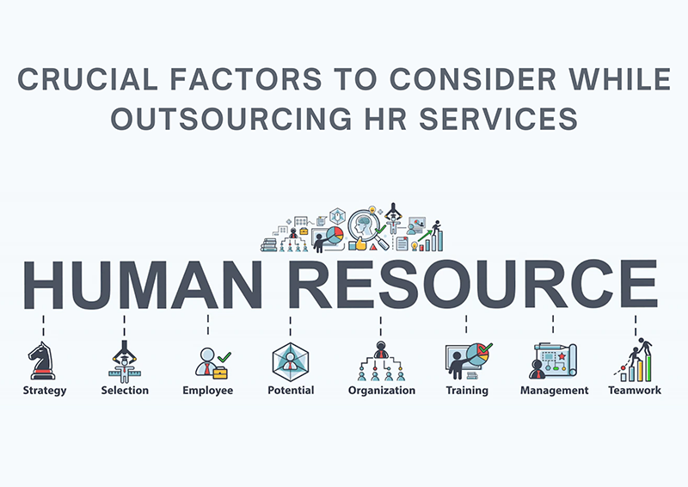

[Source](https://www.talentproindia.com/wp-content/uploads/2022/08/Crucial-Factors-to-Consider-While-Outsourcing-HR-Services-800.png)

### **Quality of Services**

It's essential to delve deeply into the recruiting firm's historical performance and reputation in the industry. Examine their track record over the years, taking note of their successes and any potential pitfalls they might have encountered. Furthermore, investigate the caliber of candidates they've previously sourced and placed with other businesses. Gather feedback, look into testimonials, and, if possible, discuss with some of their past clients. This comprehensive review will give you a clearer understanding of the firm's consistency in delivering high-quality candidates and their ability to meet the unique requirements of different businesses.

### **Availability and Accessibility**

It's crucial to ascertain that the chosen agency is both available, proactive, and responsive regarding communications and updates. Their accessibility will play a pivotal role in the smooth execution of the recruitment process. Regular and timely interactions are paramount, so ensure that they have established channels for communication and a commitment to keeping you informed. Whether through scheduled updates, periodic reviews immediate candidate feedback, or ad-hoc meetings, the agency should be well-prepared to provide insights, feedback and address any queries or concerns you might have, ensuring that you're always in the loop and confident in the process.

### **Cost**

While the allure of cost savings is undoubtedly one of the primary attractions of outsourcing recruitment, it's paramount to look beyond the financials. The accurate measure of success is the value received for every dollar spent. It's essential to balance cost-effectiveness and the quality of service provided. Assess the tangible and intangible benefits the agency brings, from the caliber of candidates they source to their expertise in navigating the recruitment landscape. Remember, a successful partnership isn't just about spending less; it's about ensuring that the investment delivers optimal results and contributes positively to your organization's objectives and growth.

### **Cultural Compatibility**

It's paramount that the recruiting firm delves deep into the fabric of your company's ethos and environment. A profound understanding of your company's culture is essential because it goes beyond just matching skill sets. The firm should be committed to comprehending your workplace's values, norms, and dynamics. This knowledge ensures that they source and recommend candidates who, beyond their technical capabilities, will mesh seamlessly with the existing team, resonate with the company's values, and contribute positively to the organizational environment. Successful recruitment isn't just about finding a qualified candidate; it's about finding the right fit for the unique cultural mosaic of your business.

## **Tips for Successful Recruiting**

### **Foster Open and Clear Communication**

Maintaining transparent and consistent communication between the company, internal recruiting team, and the recruiting firm is pivotal for the success of the hiring process. By fostering an open dialogue, both parties can continuously align their strategies, expectations, and objectives. It's not merely about sharing information; it's about ensuring that both entities understand, embrace, and pursue the shared vision and goals. Such synchronized efforts, rooted in mutual understanding, not only streamline the recruitment process but also enhance the likelihood of finding candidates who genuinely resonate with the company's mission and future aspirations.

### **Maintain a Consistent Brand Voice**

Ensuring that the recruitment agency deeply understands and aligns with your brand's distinct voice and ethos is essential. This goes beyond just knowing the basic requirements for a position in house recruiter. The agency should grasp the nuances of your brand's identity, values, messaging, and overall narrative. Such an understanding ensures that during their candidate search, they're not just looking for skills but also for individuals who can naturally embody and champion your brand's essence.

Ensuring this alignment increases the chances of hiring individuals who will perform their tasks and seamlessly integrate into and enhance the brand culture you've meticulously built.

### **Use Technology to Your Advantage**

Embracing and leveraging modern technological tools is crucial in today's fast-paced recruitment landscape. These tools, ranging from advanced communication platforms to sophisticated candidate management systems, can drastically improve the efficiency and effectiveness of the recruitment process. By streamlining communication, they ensure that all stakeholders remain on the same page and can collaborate in real time. Furthermore, with the aid of specialized software, managing candidate pipelines becomes a more organized and transparent endeavor.

Additionally, with the rise of virtual workspaces, technological tools can play a pivotal role in facilitating interviews, whether conducted in real-time video calls or through asynchronous methods. By integrating technology into the recruitment process, companies and recruitment firms can optimize their operations, ensuring a smoother, faster, and more cohesive hiring journey.

### **Continuously Evaluate and Improve the Outsourcing Process**

It's imperative to adopt a continuous improvement mindset regarding the recruitment process. Instead of viewing it as a static procedure, treat it as an evolving system that can continually be refined. Periodically assess the effectiveness of the entire process, from sourcing to onboarding. Collect feedback, analyze data, and review outcomes to identify areas that work well and may need adjustments. Doing so ensures the current process is efficient and future-proof against potential challenges. Remember, the recruitment landscape is dynamic, and staying agile by iterating and implementing improvements based on regular assessments will keep your process at its optimal best.

## **Potential Challenges of Outsourcing Recruiting and How to Overcome Them**

### **Language Barriers**

When opting to outsource overseas, it's paramount to ascertain that the recruiting firm has a strong grasp of your language. This understanding is vital for essential communication and ensuring nuances, cultural references, and specific terminologies are clearly comprehended, minimizing potential miscommunication or misunderstandings.

### **Time Differences**

When working across varied geographical areas, scheduling can pose significant challenges due to differences in time zones. To effectively manage these potential hurdles, it's essential to establish regular check-ins at mutually convenient times for all parties involved. This not only ensures consistent communication but also helps in anticipating and addressing issues proactively. Moreover, utilizing modern tools and software designed to handle and automatically adjust for time zone disparities can be instrumental.

These tools can send reminders, convert meeting times to local time zones, and facilitate seamless interactions, ensuring that geographical differences don't impede the efficiency and effectiveness of the recruitment process.

### **Maintaining Control Over the Customer Experience**

Maintaining an ongoing relationship with the recruiting agency is imperative by providing regular training sessions and updates. This ensures that they remain well-versed in your company's core values and the standards of customer service you uphold. Keeping them in the loop ensures that they continuously align their efforts with your organizational ethos and desired service benchmarks, leading to a more harmonized recruitment approach.

Outsourcing recruiting can be advantageous, offering cost savings, a broader talent acquisition pool, and improved efficiency if done right.

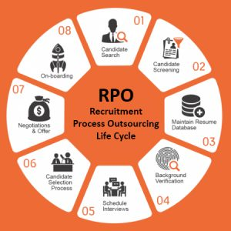

[Source](https://www.virtualrecruiters.co/wp-content/uploads/2020/11/what-is-rpo-300x300.jpg)

## **Final Thoughts on Making a Successful Outsourcing Decision**

For a successful outsourcing experience, you must partner with a recruiting agency that understands your brand, communicates effectively, and is committed to delivering top-tier candidates. Making informed decisions and continuous evaluations will ensure that outsourcing remains beneficial for your company.